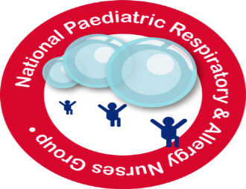

**Conference Programme Friday 15th November 2024**

**8.45 – 9.15** **Registration**

**Morning session Chair** – **Lesley Kennedy, NPRANG Chair**

**9.15 – 9.30 Welcome & Housekeeping**

**Introduce the Committee**

**9.30 – 10.10**  **Rebecca Batt – Recent developments in Allergy**

**10.10 - 10.50 Dr Prasad Nagakumar - A Year in Respiratory Medicine a summary of key papers**

**10.50– 11.20** **Coffee and Exhibition Stands**

**11.20– 12.00 Antonio McBride – OSA & Obesity**

**12.00 – 12.40 Professor Ian Sinha - Poverty**

**12.40– 13.30 Lunch & Stands**

**Afternoon chair: Ann McMurray, NPRANG Vice Chair**

**13.30 – 14.10 Gareth Jones – Vaping**

**14.10 – Poster Competition – Chair: Emma Sheppard, NPRANG Co-Vice Chair**

**14.15 – 14.30 – 2nd Prize Winner –**

**14.30 - 14.45 – 1st Prize Winner –**

**14.45 – 15.10 Coffee & Stands**

**15.10 – 15.50 Vicky Worral – Multidisciplinary Difficult Asthma Service (MDAS)**

**15.50 – 16.00 NPRANG Business and close**