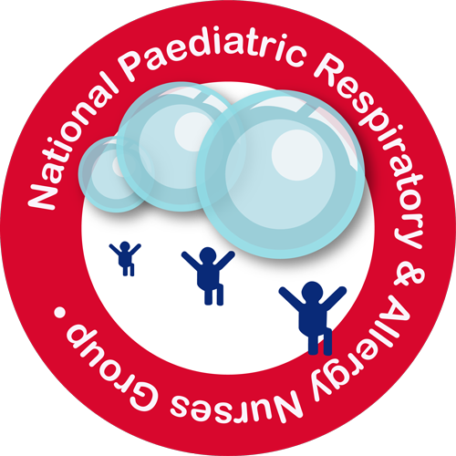

National Paediatric Respiratory and Allergy Nurses Group (NPRANG) Annual Conference Registration Form

Conference Registration Fees

Early Bird Rate: £70.00 before and including 31st July 2017
Conference full rate: £80.00 on or after 1st August until 14th September 2017

Rate includes 1 full day conference & lunch at The Forest of Arden Marriott Hotel and Country Club, Maxstoke Lane, Meriden, Birmingham CV7 7HR

BACS payment to
Name National Paediatric and Respiratory and Allergy Nurses Group (NPRANG)
Sort code 01 05 51
Account number 40611256

If not able to pay by BACs please contact Claudine.bryson@nhs.net to dicuss.

Please note
• No places can be secured for the conference unless the application is accompanied by the appropriate registration fee.
• Invoices will only be issued upon receipt of your Trust’s Purchase Order number but places cannot be guaranteed until invoices have been paid. Please provide purchase order details.
• If payment has not been received from any delegate or her/his Trust, by 14th September 2017 then the delegate will be expected to pay the full registration fee and then claim this back.

Cancellations
Standard 25% cancellation charge applies if cancelled up to six weeks prior to the event. 100% cancellation fee if cancelled within 6 weeks of the event.

Delegate Details

One Form per person, please reply on line with reply attached to Claudine.bryson@nhs.net

Full Name

Job Description

Place of Work

Address for Correspondence

Postcode

Email

Mobile

Special Dietary Requirement

Method of payment

(Claudine) Rebecca Bryson
NPRANG Treasurer
Paediatric Asthma and Allergy Nurse Specialist
Wirral University Teaching Hospital
Arrowe Park
Upton
Claudine.bryson@nhs.net

