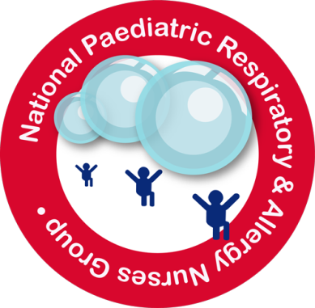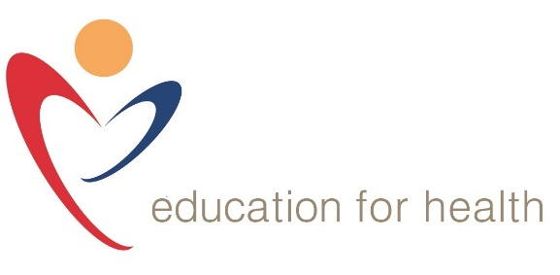
Call for abstracts for NPRANG 2017 Conference
Following positive feedback from the 2016 conference we are again calling for abstracts for thematic poster and spoken presentations. These may include reports of clinical audit, research, innovation in practice, or evaluation of clinical processes and systems. You might have a great example of good practice that you could share. Previously published or presented work is also welcome so long as this has been within the last 18 months.
The abstracts will be judged on specific criteria (see judging criteria below) by a panel of the NPRANG committee. Authors of the three highest scoring abstracts will be invited to deliver a spoken presentation and win one of the following prizes;
- 1st Prize: One place on an Education for Health academic module (diploma, degree or master’s level)
- 2nd Prize: One place on the Education for Health Allergy Professional Development Module (fully online)
- 3rd Prize: One place on an Education for Health one day educational workshop
Please note all prizes are non-transferable, subject to availability and in agreement with Viv Marsh (NPRANG Committee and Education Lead at Education for Health).
If selected for Presentation: You will be expected to deliver a 15 minute spoken presentation, with associated media, and with 5 minutes for questions.
Should you wish to submit an abstract for poster presentation only or spoken presentation only –please mark this clearly on your abstract. However, please note that prizes will be awarded for the category of those submitted for spoken presentation only
Guidelines for contributors:
Abstracts should be a maximum of 500
Key themes include: Clinical audit and research, innovation in respiratory / allergy nursing, evaluation of respiratory/ allergy nursing clinical processes and systems/projects focussed on children and families
Abstract presentation: Title, aims/ objectives, methods, findings / results.
If selected for Poster: A1 (84.1cm width x118.9cm height) or A0 (59.4cm width x 84.1height) Portrait orientation. The poster should display a clear flow of objectives, methods (or innovation/ service change) findings, conclusion and implications for further respiratory practice.

Submission deadline: 31st August 2017
If you require support with your abstract or poster please contact either:
Viv Marsh email: V.Marsh@educationforhealth.org or Sue Frost email; Susan.frost@bch.nhs.uk
Please return your completed form to: V.Marsh@educationforhealth.org

Abstract Submission Form

Abstract Full Title:

Short Title:
Author(s):
E-mail:
Telephone:
Address:

Please Detail your abstract (up to 500 words) below:
Title, aims/ objectives, methods (innovation, or service process change), findings / results/ Summary.

Abstract Judging Criteria
Can score a maximum of 3 points for each section, the abstracts will be ranked by the highest score.
The abstract is;
- Current / relevant and adds to the body of paediatric respiratory/allergy nursing knowledge
- Able to communicate and enable the reader to understand the aims and objectives
- Able to detail relevant and appropriate method / service process
- Well-presented and easy to follow – no jargon
- Able to summarise findings – and suggest future implications for respiratory/allergy nursing practice

Maximum score = 15 points

