NOW AVAILABLE

3RD edition of

Food Challenges for Children A practical guide

by Heidi Ball and David Luyt

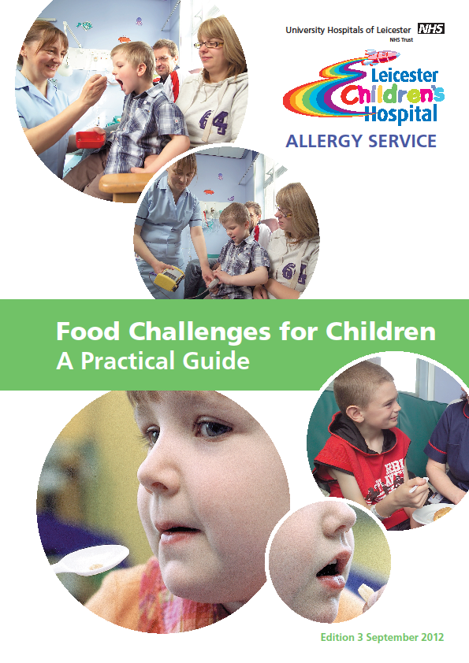
Content Index
- Identifying patients for oral challenges.
- Value of allergy tests
- Setting up for food challenges
- Medical guidance
- Challenge procedures
- Challenge plans for 14 different foods
- Food challenge recipes
- Home reintroduction plans
- Guidelines & documentation
- Photographs
- References

Price: £15 per copy

Contact childrensallergy@uhl-tr.nhs.uk for order forms

